Year 11

GCSE

SPaG Revision Booklet

Spelling

Spelling Rules
A lot of spelling is regular, meaning that it follows rules and patterns. Here are some of the most useful rules – but there are (unhelpfully) exceptions to nearly all of them.

i before e except after c
- achieve
- receive
- believe
Changing y to ie
- Change the y to ie when adding s to a word ending in y
  - berry – berries
  - pity – pities
but only if there is a consonant before the y. If there is a vowel (a e i o u) before the y, you just add s.
  - boy – boys
  - say – says
Follow the same rule when you add ed
  - pity – pitied
These are just a few. There are lots more spelling rules.
See your English teacher if you want a full run down of them all!
  - play – played

The suffix ful only ever has one l.
  - hopeful
  - shameful
The suffix less always has two ss.
  - thoughtless
  - hopeless

Homophones
Revise these common homophones.
Write a sentence that uses each word correctly
buy | by | The old lady went to buy a hat from the shop by the cinema.
four | for
hear | here
hole | whole
know | no
one | won
peace | piece
right | write
to | too
there | their
wear | where

Spelling Strategies

Way to spell | Explanation | Example
Sound it out | Carefully say the word out loud and make sure you write down each phoneme (sound). | m-e-t-a-ph-or
Break it down and sound it out | Break the word into syllables. Say each syllable, and write down each one. | Sole - dad
Find the stem word | Some long words are just short words with bits stuck on. | Thoughtlessness  Stem word ‘thought’  Suffix less and ness
Memory tricks | Invent memory games to help you remember hard words. Add pictures to help even further. | onomatopoeia  Onomato (that bit’s easy)    poor old elephants in africa
Look, say, cover, write, check | Look carefully at the word, say it, cover it up, write it down, check if you were right. Repeat until you get it right. | Try tricky words that you get wrong like this:  beginning  Steinbeck  Shakespeare
Say it like it is | Some words have silent letters. When you say these words, say their silent letters too. | Wed-nes-day

The Dirty Thirty
Lots of people spell these ones wrong – make sure it’s not you.

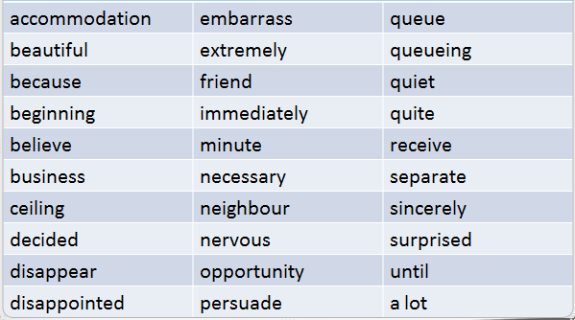

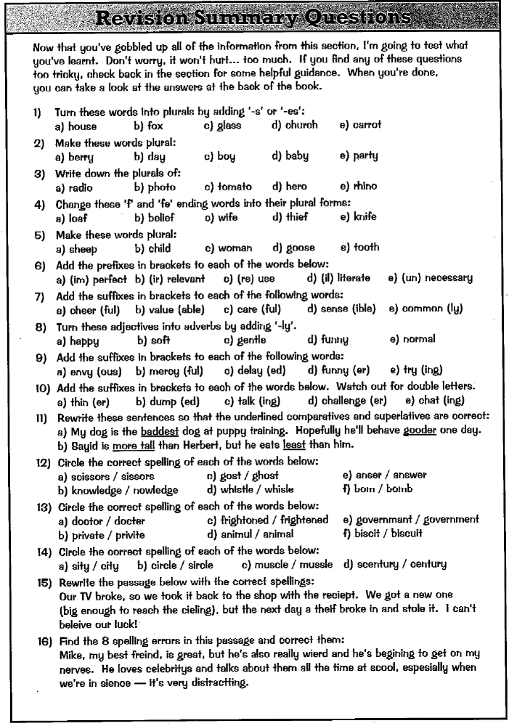

Punctuation
Full Stops and Capital Letters

Use a capital letter:
- At the start of a sentence
- Some words always begin with a capital letter
  - The first person singular I.
  - People’s names – Romeo loved Juliet. Steinbeck wrote about George and Lennie.
  - Titles of books and plays: ‘An Inspector Calls’, ‘Of Mice and Men’, ‘The Farmer’s Bride.’
  - Towns and places: Ipswich, Soledad, Weed
  - Names of days and months: Saturday, November
Use a full stop:
At the end of every sentence – remember to keep sentences short and to the point.
Use an exclamation mark:
At the end of a sentence that shows strong feeling. You can use an exclamation mark:
- If the sentence is a command – Bring me your homework!
- For someone shouting – Stop! Now!
- To show a strong emotion – It was amazing!

Quotes
When quoting from the text you must use the exact words, put those exact words in quotations marks and introduce the quote with a colon (:) …we know this because Steinbeck writes: “I seen too many guys with land in their head. They never get none under their hand.” Any punctuation from the quote should come within the quotation marks.
However, it is more sophisticated to embed your quotes into the sentences you are writing. For example: Lennie and George are going to “live of the fatta the lan’.”

Apostrophes
Apostrophes are used to show omission (something is missing) or possession (belonging to something).
Only use apostrophes for omission when writing informally. In formal writing you should write words in full. When you do use an apostrophe, put it where the missing letter or letters would have been:
- You shouldn’t have done that.
- Ethan’s finished but Rachel’s still working.
- Let’s go home.
Apostrophes for possession show ownership. If the owner is singular, or a plural and does not end in s, add an apostrophe and an s to the word that indicates the ‘owner’:
- the cat’s tail
- the class’s teacher
- the children’s toys
- James’s hat.
The only time you have to do anything different is for a plural ending in s. In this case, simply add an apostrophe:
- the cats’ tail
- the boys’ team

It’s and Its

It’s means it is or it has.
If you write it’s with an apostrophe, you must always use it to mean it is or it has. The apostrophe shows that letters have been missed out.
It is raining today It’s raining today
It has been a great year for ostriches. It’s been a great year for ostriches.

Its shows that something belongs to it
If there’s no apostrophe then its shows something belongs to it (whatever it is).
The whale flipped its tail.
The chipmunk opened its pack of nuts.

Colons and Semi-Colons

Colons are used before an explanation:
- It took two hours: it was a difficult job.
They introduce quotations:
- Macbeth is going mad: “Is this a dagger I see before me?”
They introduce lists:
- The collection was wide and varied: historic manuscripts; suits of armour; ancient bones; and hundreds of gold coins.
Semi-colons
Semi-colons are used to separate the items in a list that consist of more than one word (as in the example above). The semi colon helps with clarity.
Semi-colons are also used to show that two clauses are closely related, when the writer does not want to use a connective or a full stop:
- The flowers are blooming; the trees are green.

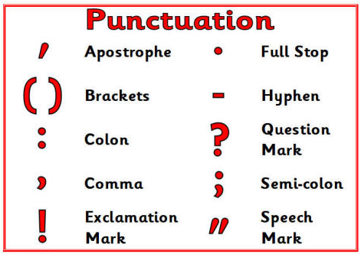
An extra word – you get good marks for using a range of punctuation. That means any of the punctuation below – as long as you use them correctly. Ask your English teacher if you’re not sure what some of them are for.

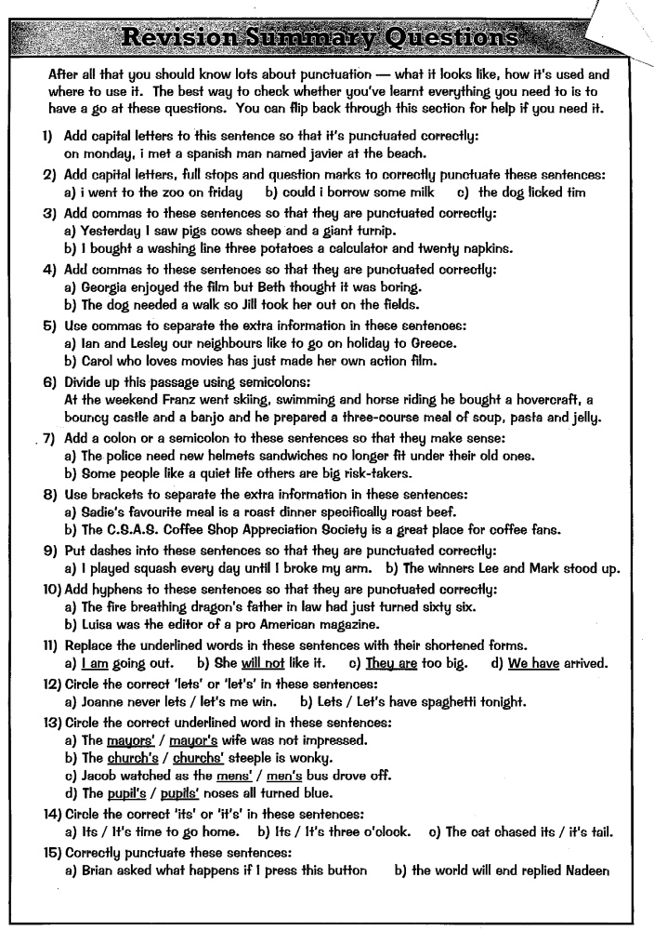
Text Structure and Organisation

Paragraphs

Paragraphs are important for making sure that your writing is presented well and easy to read.

Make the beginning and the end clear.
- Lay out paragraphs correctly
- Leave a gap before you write the first word of each paragraph.
- At the end of each paragraph put a full stop and then leave the rest of that line blank.

Use a double strike to show new paragraphs.
If you forget to start a new paragraph, you can use a double strike to ( // ) to show the reader where the new paragraph should have started.

TiPToP Paragraphs

Start a new paragraph each time you introduce or discuss a new
Time Place Topic or Person.

Start a new paragraph for each new point…

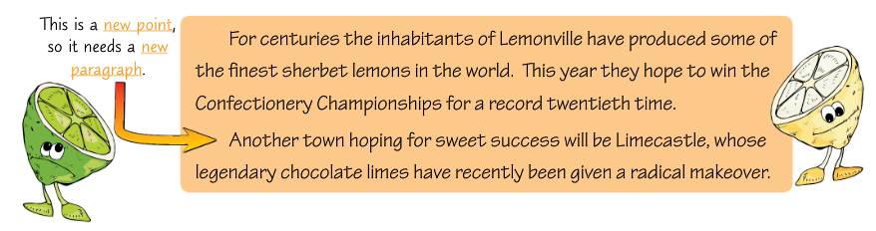

Aiden was bored. The television was broken, the Internet was
down and even the cat had disappeared.
After a while, the phone rang and Aiden ran into the kitchen to
answer it. It was Hannah.
“Hi Aiden! Are you busy?” she asked. “Something incredible is
happening outside – you should come round and have a look,” she
said, clearly very excited.
“What’s happening, Hannah?” Chris was bored but he didn’t want
to go out in the rain unless it was something really worth seeing.
Hannah had already put the phone down, so Aiden had to take a chance and go and see for himself.
When he got to Hannah’s house, he couldn’t believe his eyes – the whole front garden was covered in frogs.
Time

Speaking

Speaking

Place

Topic Sentences

Topic sentences are a neat way to start your paragraphs to show that you have planned your writing and know what the content of the paragraph is going to be. They don’t need to be long but they are effective:
  - Steinbeck uses imagery throughout ‘Of Mice and Men’…
  - ‘Lord of the Flies’ uses symbolism throughout…
  - ‘An Inspector Calls’ is a play about social attitudes…
  - Both poems use alliteration for effect…

Connectives

Discourse markers connect sentences and paragraphs. They guide readers through the text, showing how one sentence relates to another and how one paragraph relates to another.
They can be single word connectives, such as however, or phrases such as in addition to this.
Not all connectives have to be used at the beginning of a sentence. They can be just as effective a little way in.

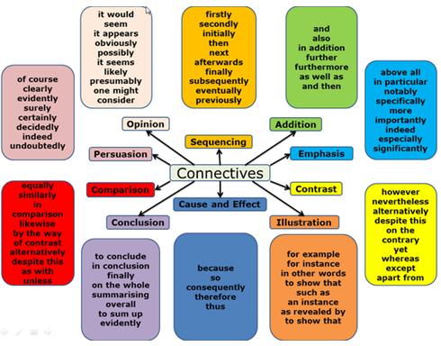

Quick Test
Identify the connective in the following sentence and explain their purpose:
- First, I will consider Bobby’s proposal.
- Noah’s idea, on the other hand, is ridiculous.
- Before the bus shelter was built, there was no vandalism.
- I suggest, therefore, that we demolish the bus shelter.

Other Important Things to Remember

Standard English
Standard English is posh writing. Standard English and non-standard English are different.
- Standard English follows spelling, punctuation and grammar rules.
- Non-Standard English doesn’t follow formal rules. It’s a more informal type of English.

- Non-Standard English is found in speech.
- People sometimes use non-Standard English with they speak. You need to use Standard English in your writing.
- Using Standard English makes your writing clear and easy to understand. It’s good for most types of writing and is essential for essays in exams.
- Non-Standard English can make your writing sound friendly and chatty. Using non-Standard English might also make people think you can’t use SPaG correctly, so it’s best to stick to Standard English for most work.

Modal Verbs
It’s easy to get have and of muddled up, so it will help learn the verbs that use have.

The verbs in the sentences below often use have but never use of.

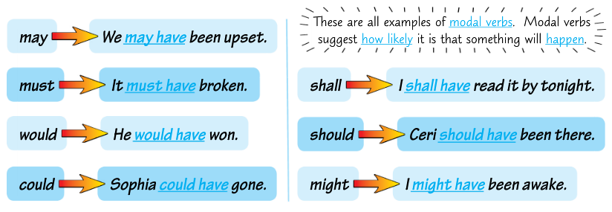

Proof Reading
Spending time reading your work over at the end of ANY exam is ESSENTIAL. To do this effectively, make sure you:
- leave enough time – a minimum of five minutes
- do it really carefully – pay attention to every word and piece of punctuation.
- check for all areas of SPaG.
- put your fingers in your ears and whisper-read.

Further Advice

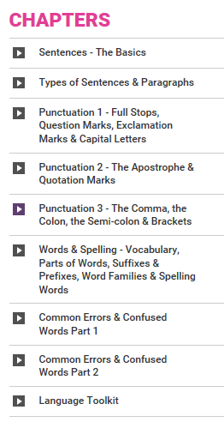
GCSEPod has some good podcasts
https://www.gcsepod.com/

Mr Bruff has lots of good advice on SPaG
https://www.youtube.com/playlist?list=PLqGFsWf-P-cAs4w-AQ9_5izpACHpxM0HN

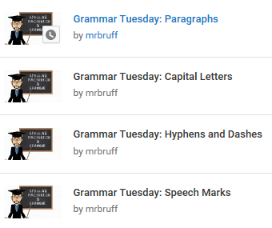

Good Luck!

