Dear parents and carers,
Enclosed is your son/daughter’s Record of Achievement report which provides an indication of their performance in the first half of this academic year.
The report is split into three sections:
1) Examination subjects
2) Practical based subjects
3) Details of assessment and resources to help improvement.
Section One: Examination Subjects
Exam result %
In January, students sat their first KS3 examination, all students sit the same assessment within subjects. The assessments are designed to test what students know, understand, and can do and to get progressively more challenging throughout Key Stage Three. Individual performance in the examination is reported as a percentage.
Year average %
The cohort average percentage is reported to provide some helpful context when considering individual results.
Relative Progress
After each assessment, teachers will mark and moderate the work of the students to ensure accuracy of marking. Individual student scores are then evaluated to determine how much progress has been made since their last assessment. This is then compared with the progress made by the rest of the students in the year group and results in a relative progress score:

++ | Students’ knowledge, understanding and skills have developed significantly further compared to similar students in their year group.
+ | Students’ knowledge, understanding and skills have developed further compared to similar students in their year group
= | Students are building knowledge, understanding and skills broadly in line with similar students in their year group.
- | Students’ knowledge, understanding and skills continue to develop, but not quite as far as similar students in their year group.
-- | Students’ knowledge, understanding and skills have not developed to the same level as similar students in their year group

Attitude to Learning
This grade reflects the behaviour, attitude and commitment shown by a student within the lesson. The POSITIVE criteria shown below is used by teachers when awarding this grade.
Determined | consistently display POSITIVE habits in the lesson.
Engaged | often displays POSITIVE habits in the lesson.
Compliant | Sometimes displays POSITIVE habits in the lesson.
Reluctant | Rarely displays POSITIVE habits in the lesson.

Below is an example of a report for mathematics with guidance on how to interpret the report.
Subject | Exam Result (%) | Cohort average (%) | Relative Progress | Attitude to Learning
Mathematics | 61% | 52% | ++ | Determined

Student A is performing well in this subject. The relative progress score indicates that excellent progress has been made since the last assessment, when compared with the rest of the cohort. They have an Attitude to Learning grade of ‘Determined’ which shows they are consistently demonstrating the POSITIVE learning behaviours we expect from our students in the classroom. The exam result reveals that there are some areas of knowledge that student A should aim to embed as, although they are performing above the cohort average, there is still room for improvement. The link to the improvement resource for mathematics will provide a useful starting point.

Section Two: Practical based subjects

Assessments in our practical based subjects are based on student performance in their project work within lessons. Students are assessed using the following:

- Highly developed
- Secure
- Developing
- Emerging
- Introducing

Subjects use a holistic approach when awarding these grades, they take into consideration a range of skills and knowledge. Further details can be found in section three of the report.

Section Three: Details of assessment

This section should be used to help students reflect and identify their gaps in knowledge. The focus of our assessment system is to determine rates of progress through the Key Stage Three curriculum and identify gaps in subject knowledge so that students can be supported accordingly, and gaps are closed. The ‘resources to help students improve’ should provide a useful starting point. You can click on each subject on the main section to take you to their assessment and improvement page.

Frequently Asked Questions

How is Relative Progress calculated?

Relative Progress allows us to monitor student achievement and compare it to their starting point in Year 7 or previous assessment point. It also takes into account the performance of the rest of year. Relative progress is calculated by evaluating the performance of the whole year group on an assessment and whether an individual student has made progress in line with other students, depending on their starting point.

Does an = Relative Progress score mean that my son/daughter is not making progress?

No, an = means that a student is maintaining their progress in relation to others in the year group and their previous assessment result. As our assessment system increases in challenge in line with our Key Stage Three curriculum an = means a student is meeting the demand of that challenge and sustaining their progress.

How is the Reading Percentile Rank calculated?

Throughout Key Stage Three, students are regularly tested using the online Star reading tests. This provides a snapshot of reading ability and generates a percentile score. A percentile rank of 40 or above is in line with our expectations.

What happened if my son/daughter missed the assessment?

In this assessment cycle teachers were asked to input a Teacher Assessed Grade using their professional judgement and other classroom based assessments. This is so that we can generate a Relative Progress score in the next assessment and reporting cycle.

Why is the Relative Progress score missing for a subject?

As a Relative Progress Score relies on having a previous assessment point, if an end of year assessment in Year 7 or 8 was not completed, relative progress cannot be calculated. Instead, you will see their percentage score which can be compared to the year average as a helpful guide to current achievement alongside Attitude to Learning.

Some subjects have higher average percentages for the year, does this mean that students are doing better in that subject?

No, subject teams have meticulously designed these assessments to test what students know and can do within that subject. Naturally, there will be variability within the design of the assessments across subjects but it does not mean that students are doing ‘better’. It is unhelpful to compare percentages across subjects. Instead, looking within a subject at the Attitude to Learning grade, Relative Progress score and percentage score when compared to year average is most helpful to get an informed insight into how your son/daughter is progressing.

What does the Attitude to Learning grade mean?

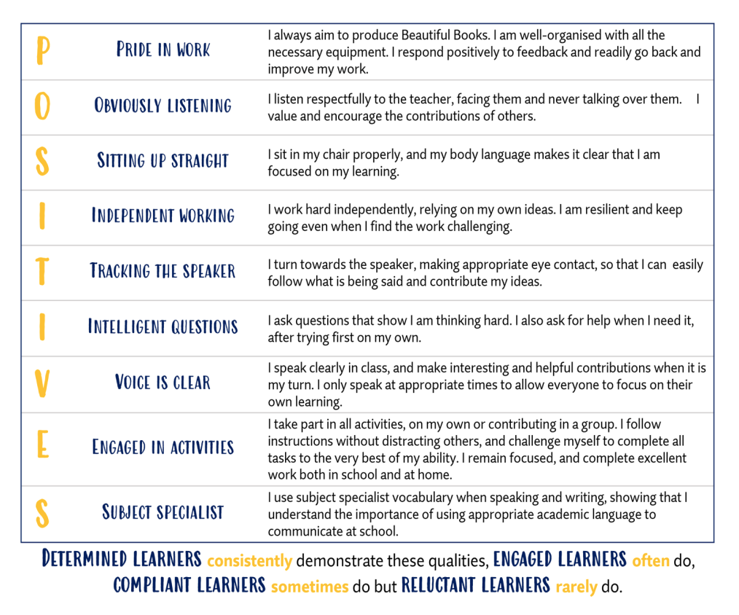
Teaching staff make a judgment about Attitude to Learning using our POSITIVES criteria, which all students are aware of. We encourage our students to display these learning behaviours within their subjects to maximise their learning and reach their full potential. The criteria is below:

How do teachers of practical subjects measure progress?

Each practical subject differs slightly but across all practical subjects students are expected to work on extended projects and practice to hone their skills, knowledge and understanding across a range of disciplines. Progress is measured either in a final project or holistically over the first half of this academic year.

I have questions for the subject teacher, what should I do?

Please email info@earls.dudley.sch.uk and clearly state the subject and teacher, we will ensure your enquiry is passed on to the relevant member of staff.

